Jenkins -01

1.gthjInstall Jenkins and run Jenkins on port number 8080.
Task Title:
Install Jenkins and run Jenkins on port number 8080

Objective:
Installing JENKINS and changing the port number 8080 -->8081

Prerequisites:
- EC2 instance with 15-20 gb of Volume
- Java Package of version 17
- JENKINS package

Step by Step Implementation:

Step 1: Launch an EC2 Instance with required Configurations
Step 2: Connect the ec2 using git bash

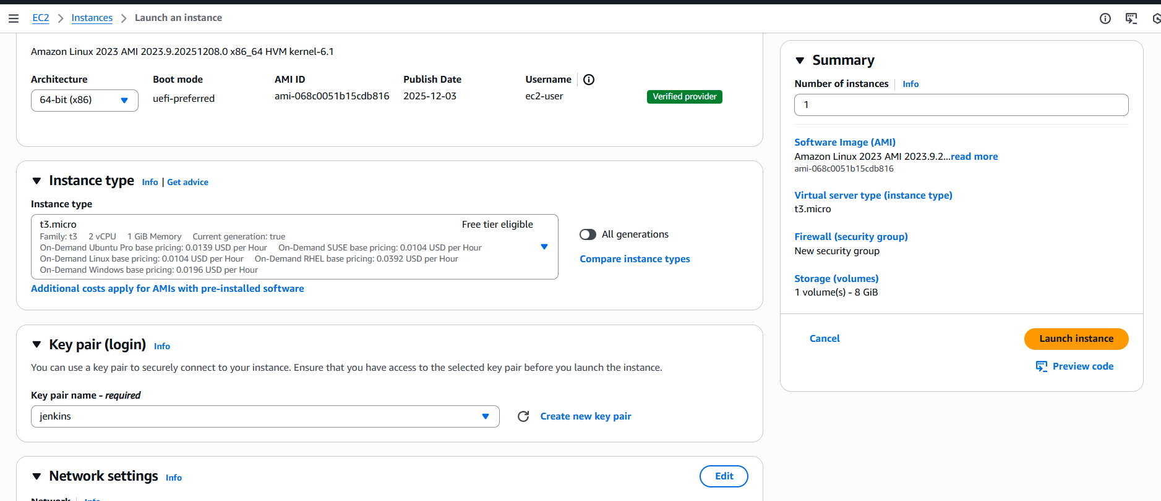
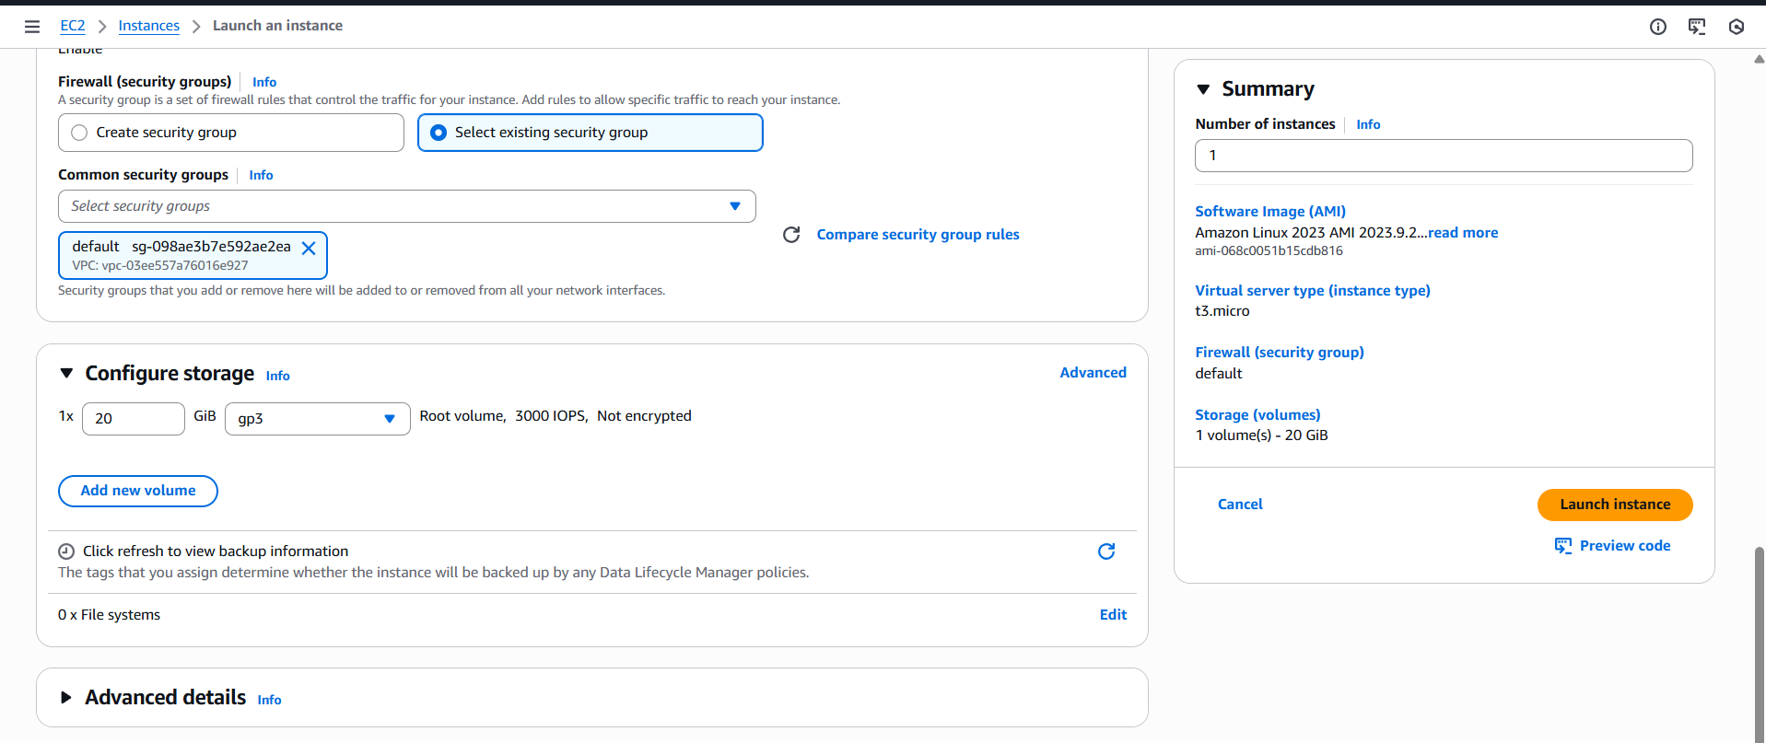
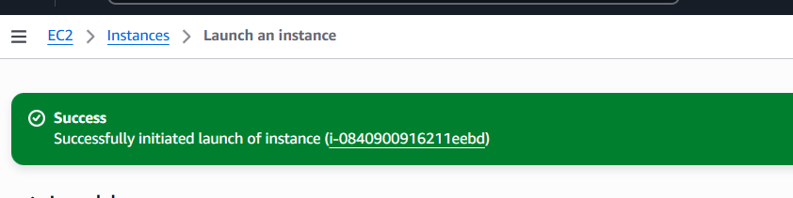
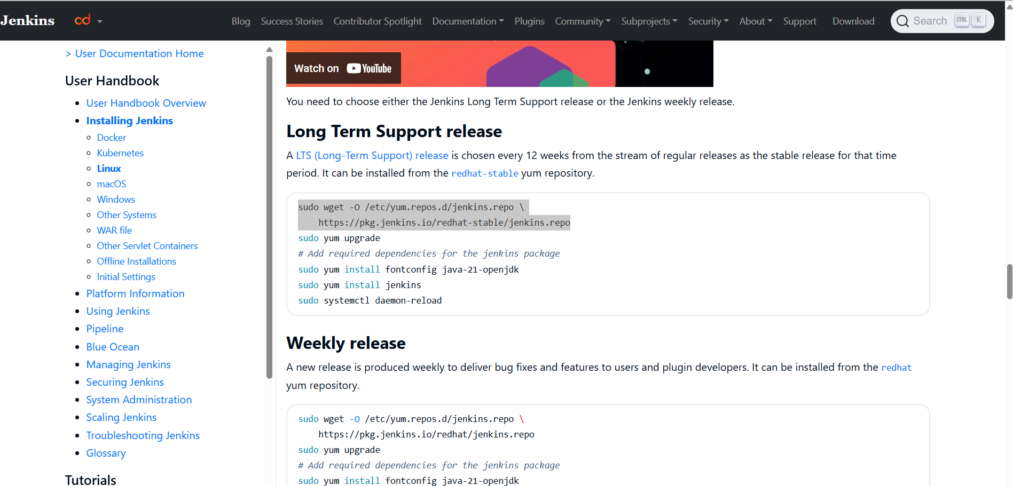

Step 3: Connected In git bash and updated the dependencies
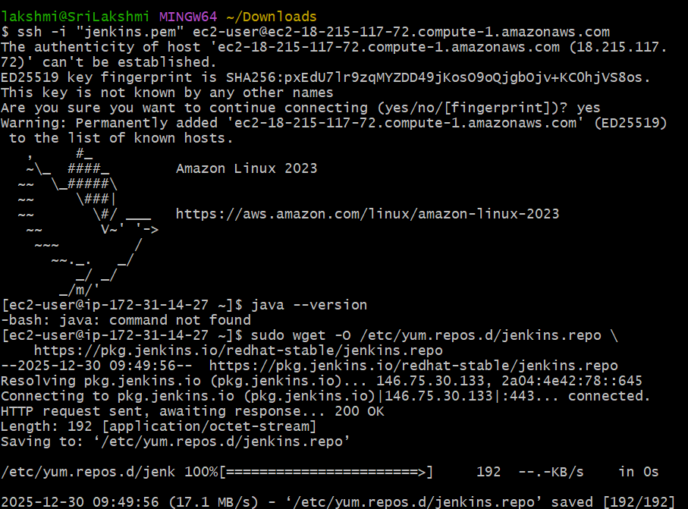
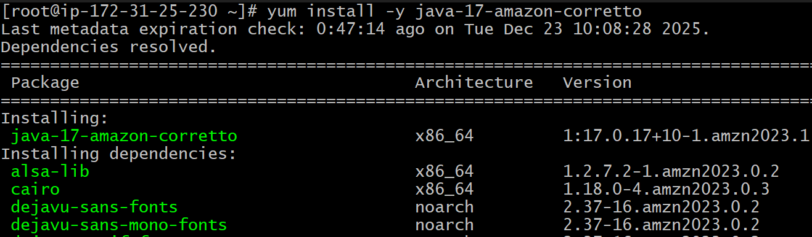
Step 4: Install java version of 17 in ec2

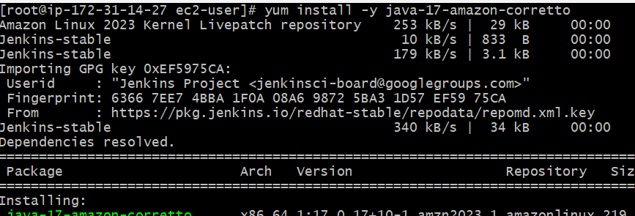
Step 5: Use the Link to download the Jenkins package and rpm keys
Download jenkins Repo:
=====================
sudo wget -O /etc/yum.repos.d/jenkins.repo https://pkg.jenkins.io/redhat-stable/jenkins.repo

Import the jenkins key:
======================
sudo rpm --import https://pkg.jenkins.io/redhat-stable/jenkins.io-2023.key

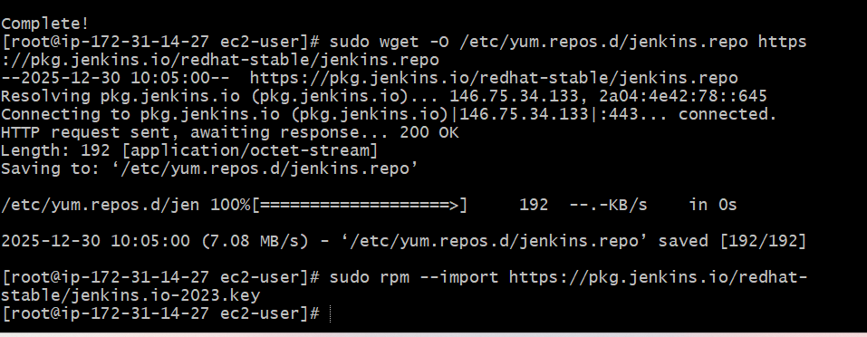

Step 6: Use the Command to Install Jenkins.
And start the service and check the status in cli and GUI
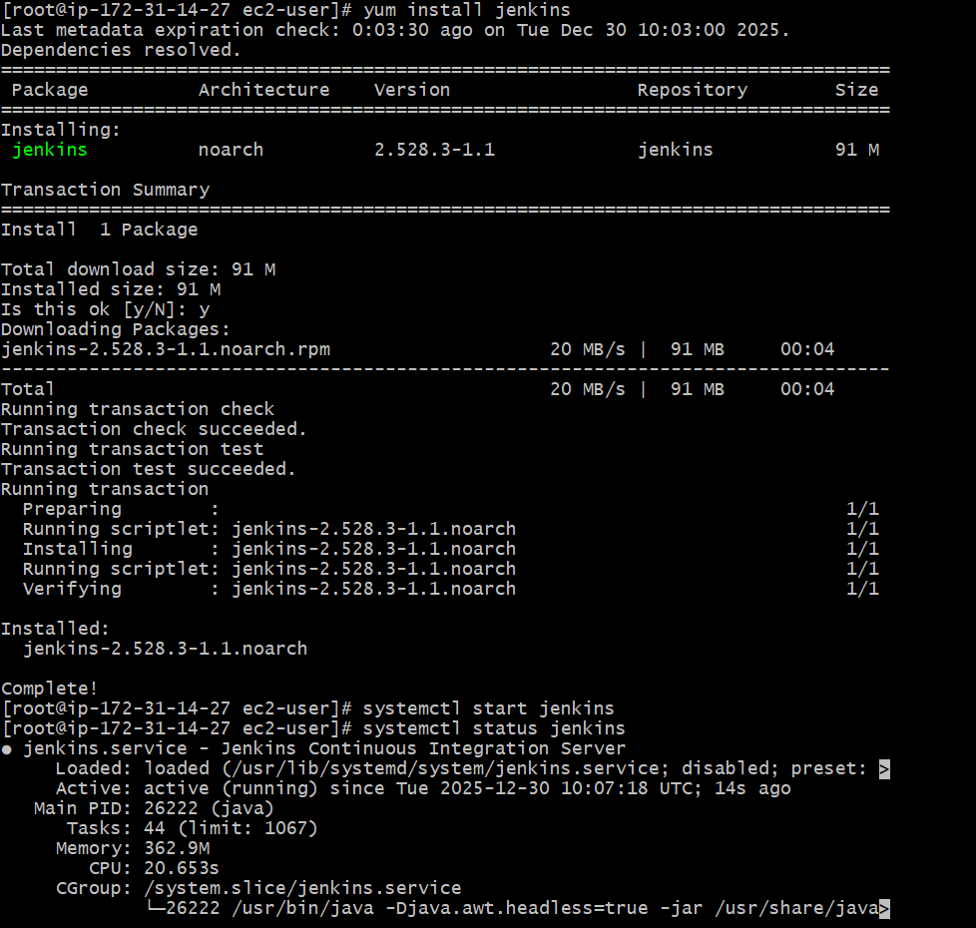
Systemctl start Jenkins
Systemctl status jenkins
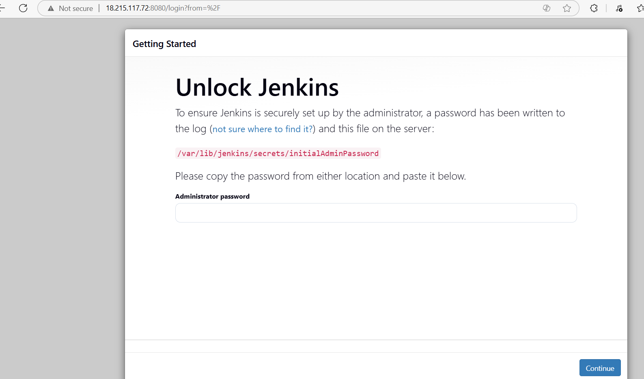

FOR CHANGING PORT NUMBER
Default location of file is /usr/lib/systemd/system/Jenkins.service
Use vi to access the file and change the port number 8080 to 8081

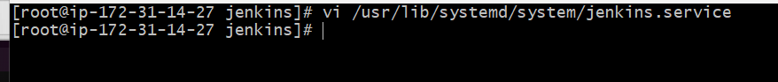

Conclusion::
Jenkins was installed successfully and configured to run on port 8081, and the service is running properly and accessible through the browser.

2.Secure Jenkins server

Title:
Secure Jenkins server

Objective:
To secure the Jenkins server by restricting unauthorized access, configuring proper authentication and authorization, securing network access, and protecting sensitive credentials to ensure safe and reliable CI/CD operations

Prerequisites::
- Jenkins
- Create Admin User
Step By step Implementation::
Step 1: Click on Suggested Plugins and continue to install
Step 2: Create a ADMIN User and provide the details and submit

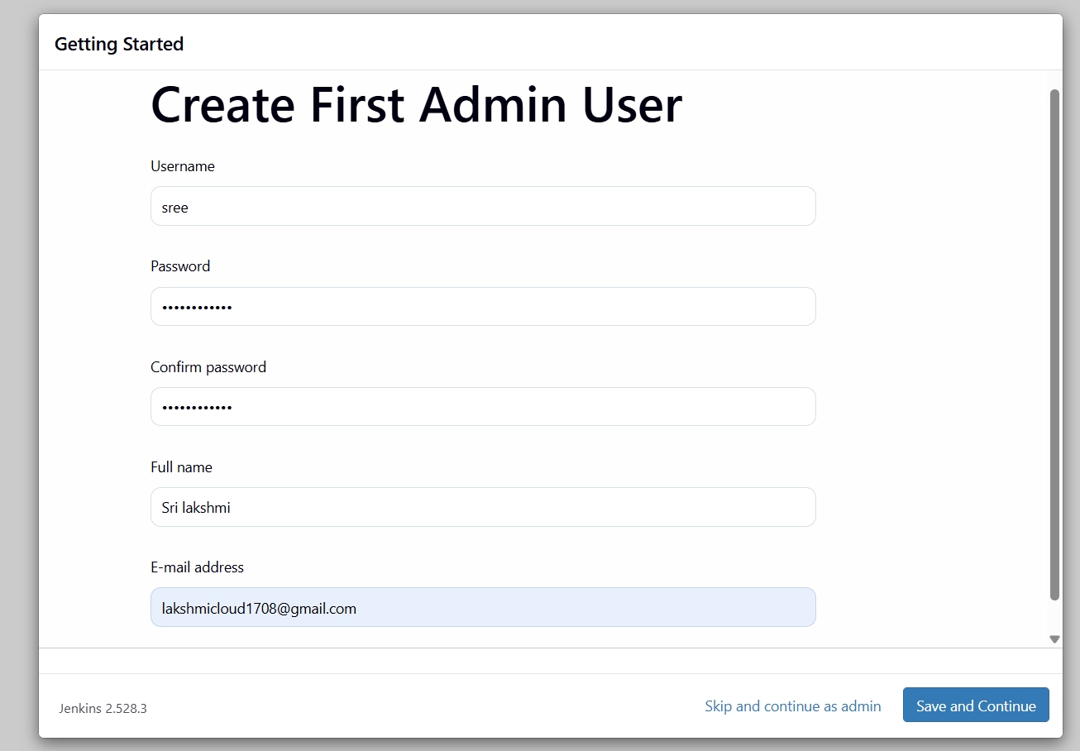
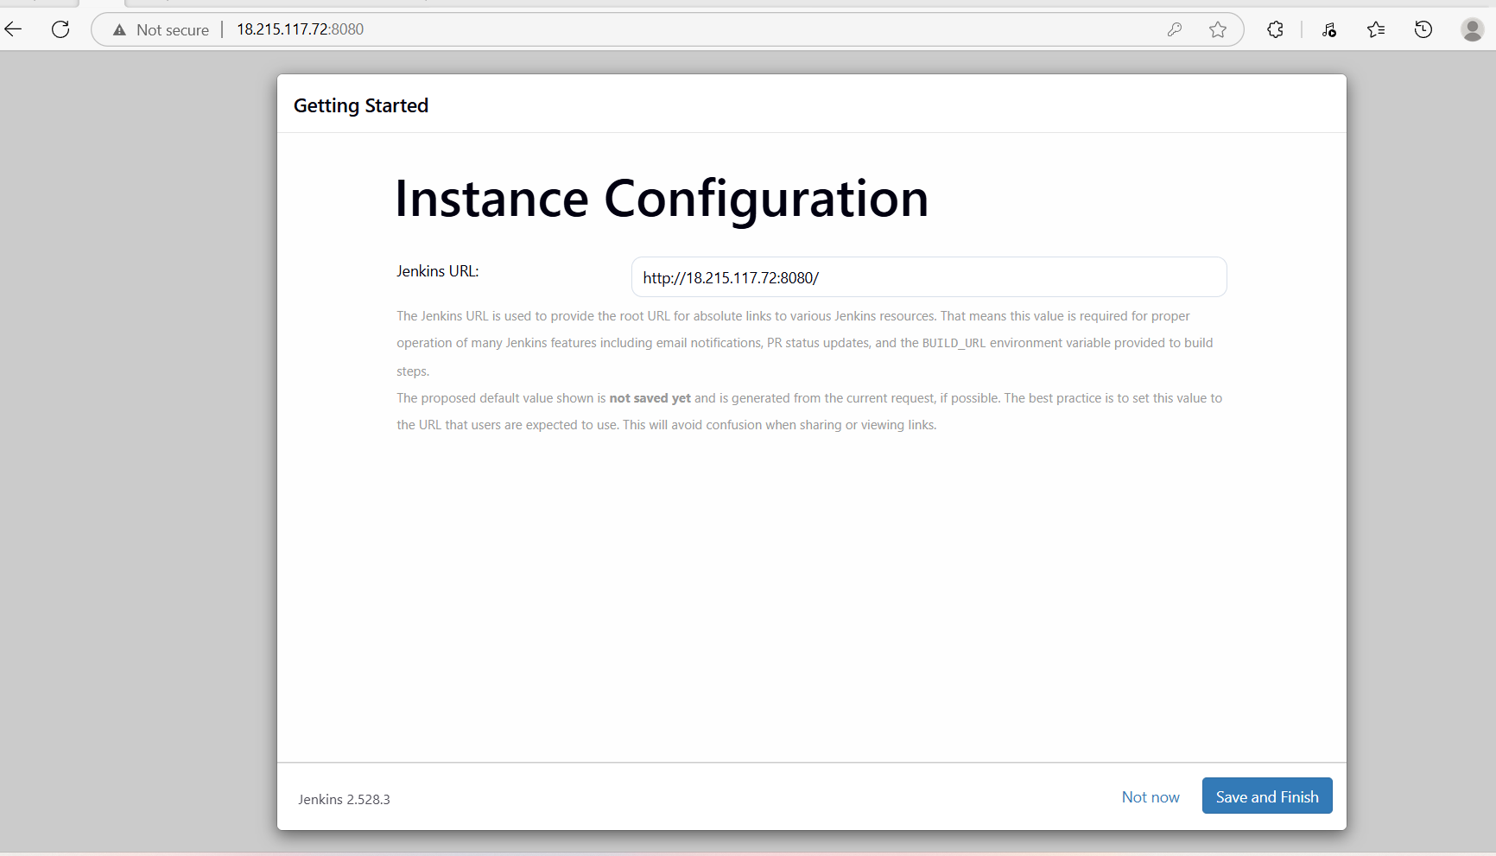
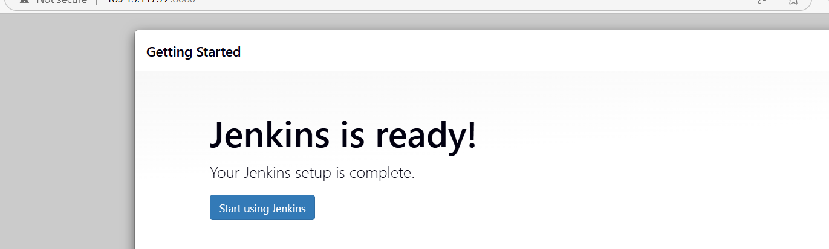

This is ADMIN DASHBOARD

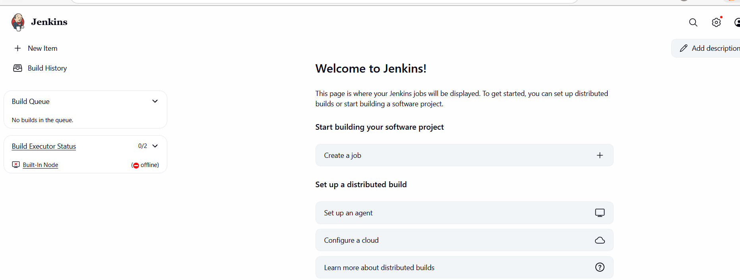

Validation Step:: Earlier there was a file called InitialAdminPassword as you can see in below document but after Securing by creating ADMIN User the file was not visible
So that our JENKINS is Secured with our USERNAME AND PASSWORD

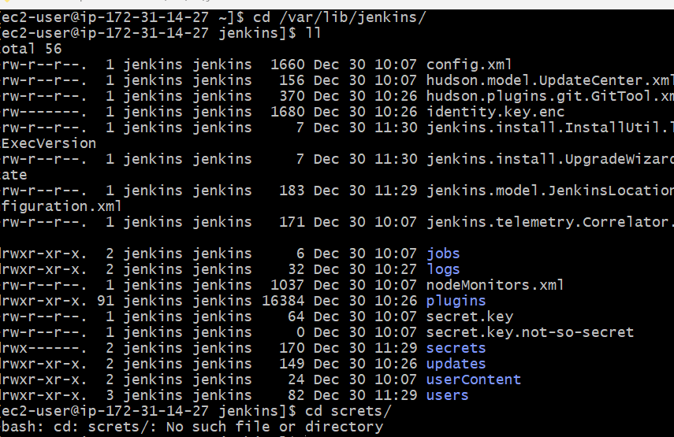
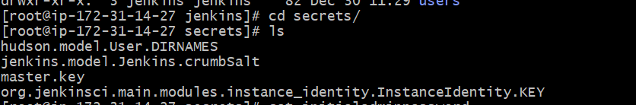
Conclusion:
The Jenkins server was successfully secured by applying access controls, enabling authentication, restricting network ports, and safeguarding credentials. These measures reduce security risks and ensure that Jenkins operates in a safe and controlled environment suitable for production use.
3.Create users called DevOps, Testing in Jenkins with Limited access.
Title:
Create users called DevOps, Testing in Jenkins with Limited access.
Objective:
To create Jenkins users named DevOps and Testing and assign them limited access by configuring role-based permissions, ensuring users can perform only authorized actions according to their responsibilities.
Prerequisites:
- Jenkins
- Plugins (Role -based)
Step by Step Implementation:
Step 1: Navigate to Jenkins Dashboard

Step 2: Click on Settings and navigate to Users tab and click on it
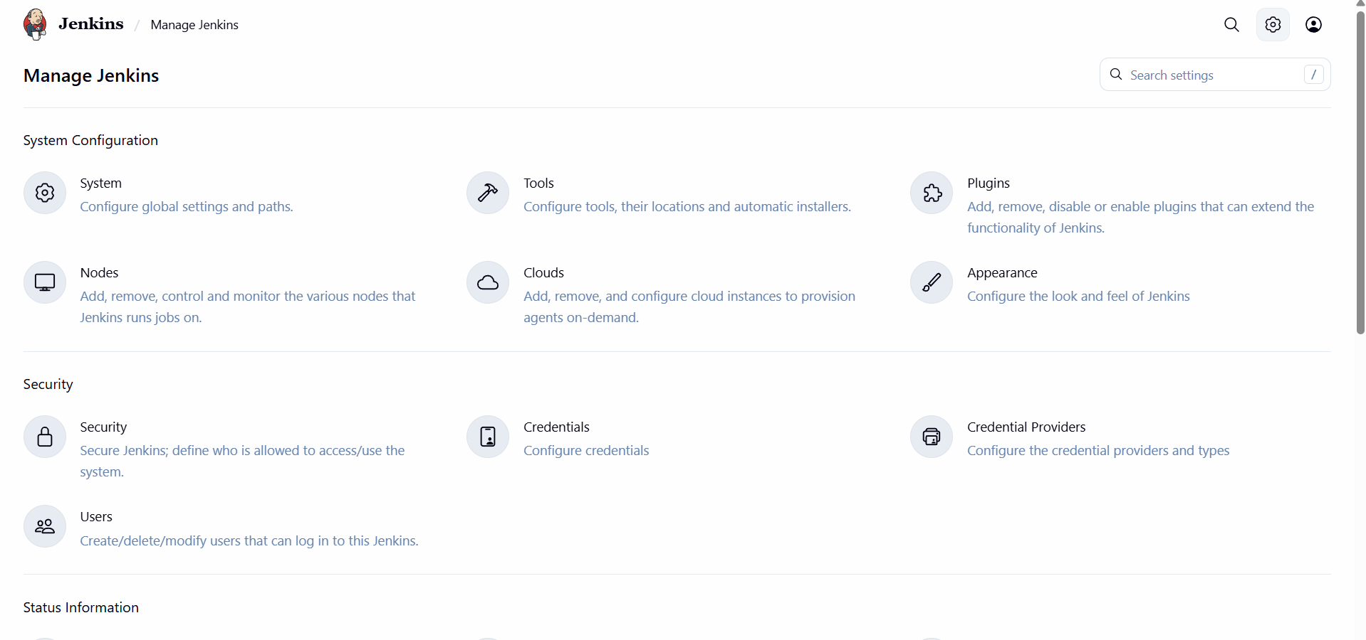
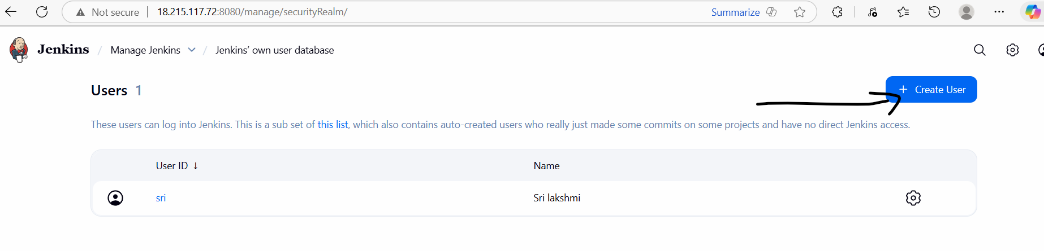
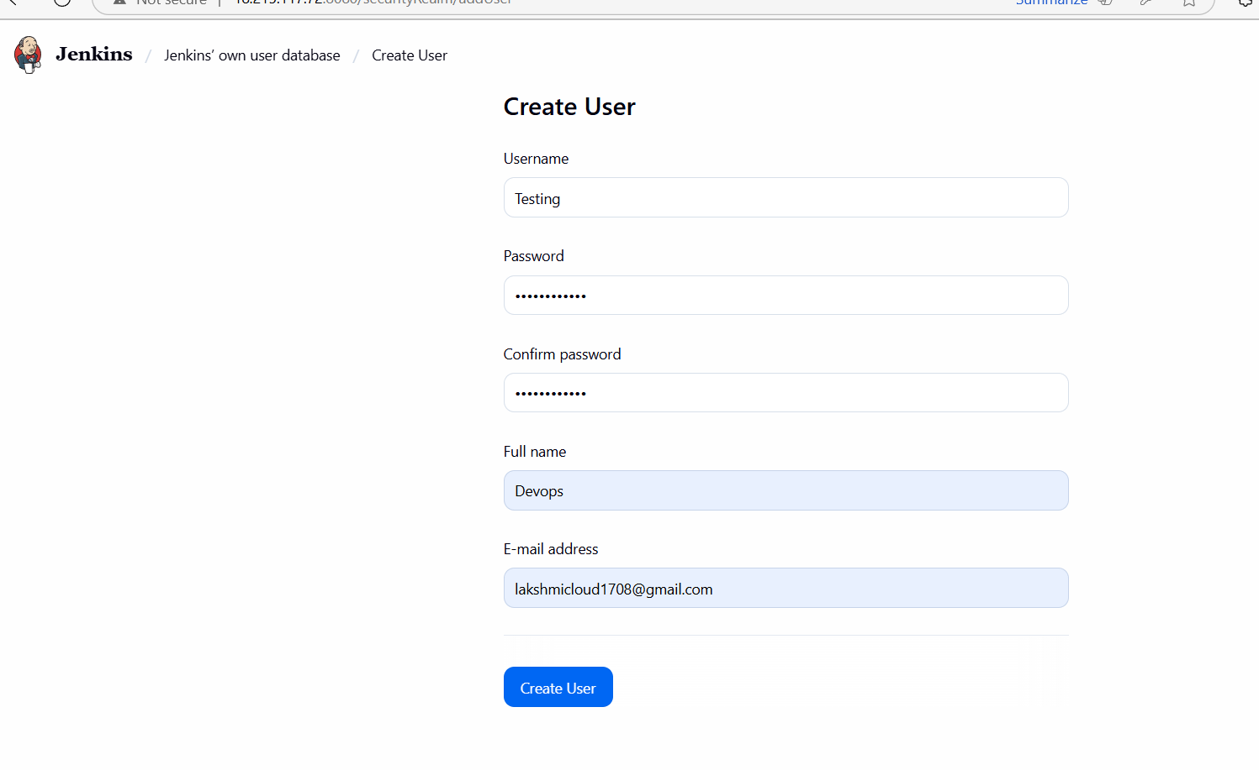
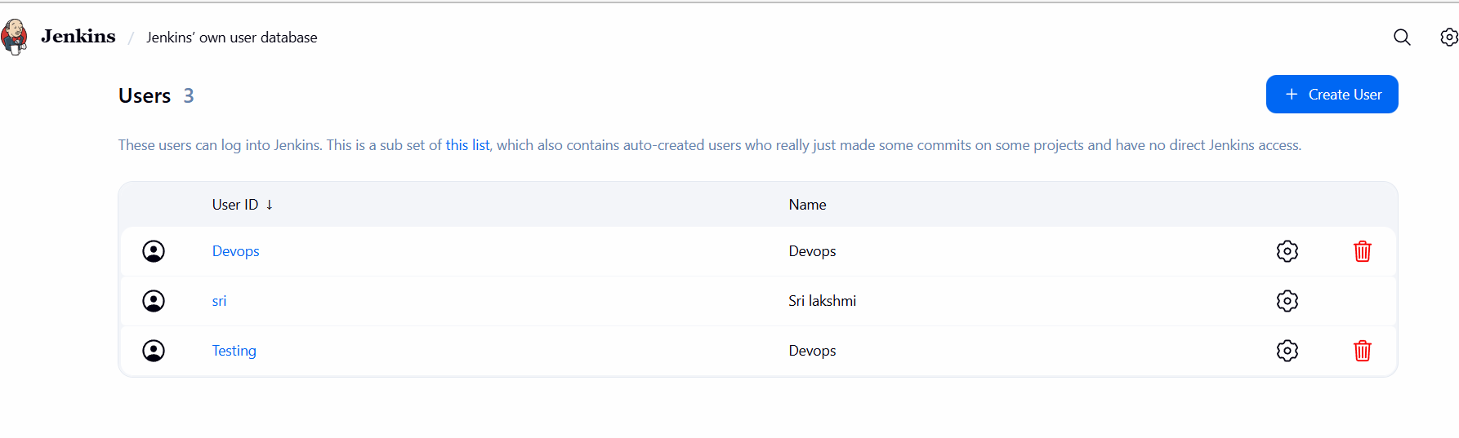
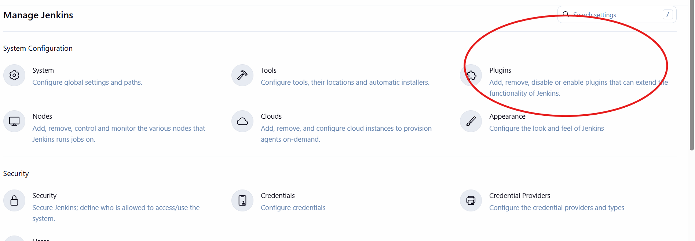
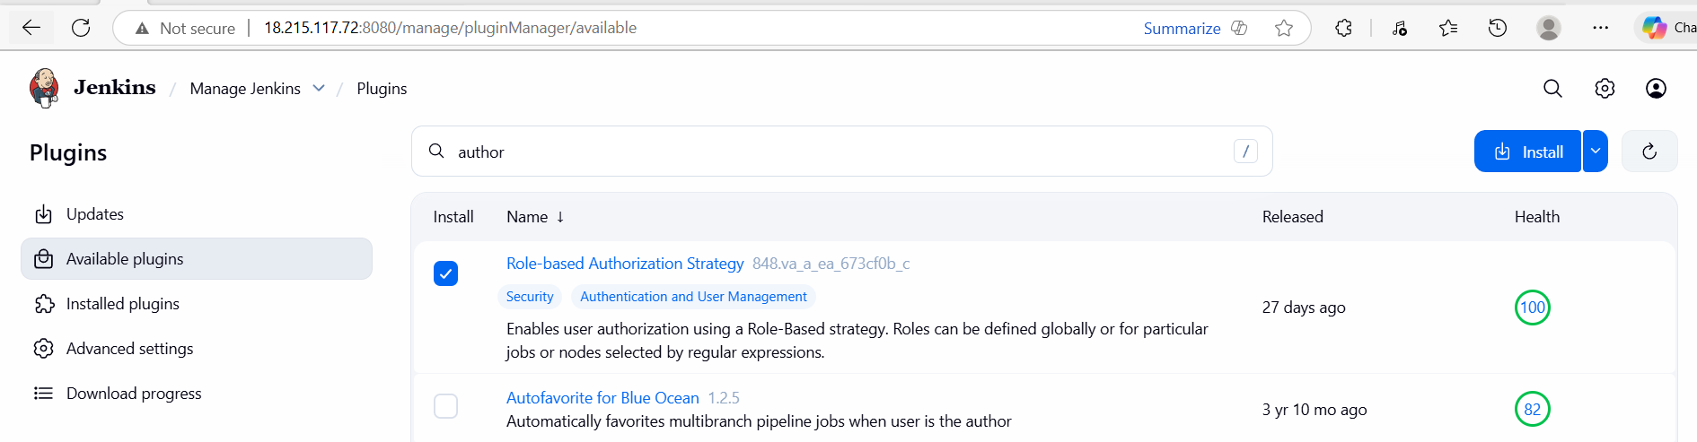
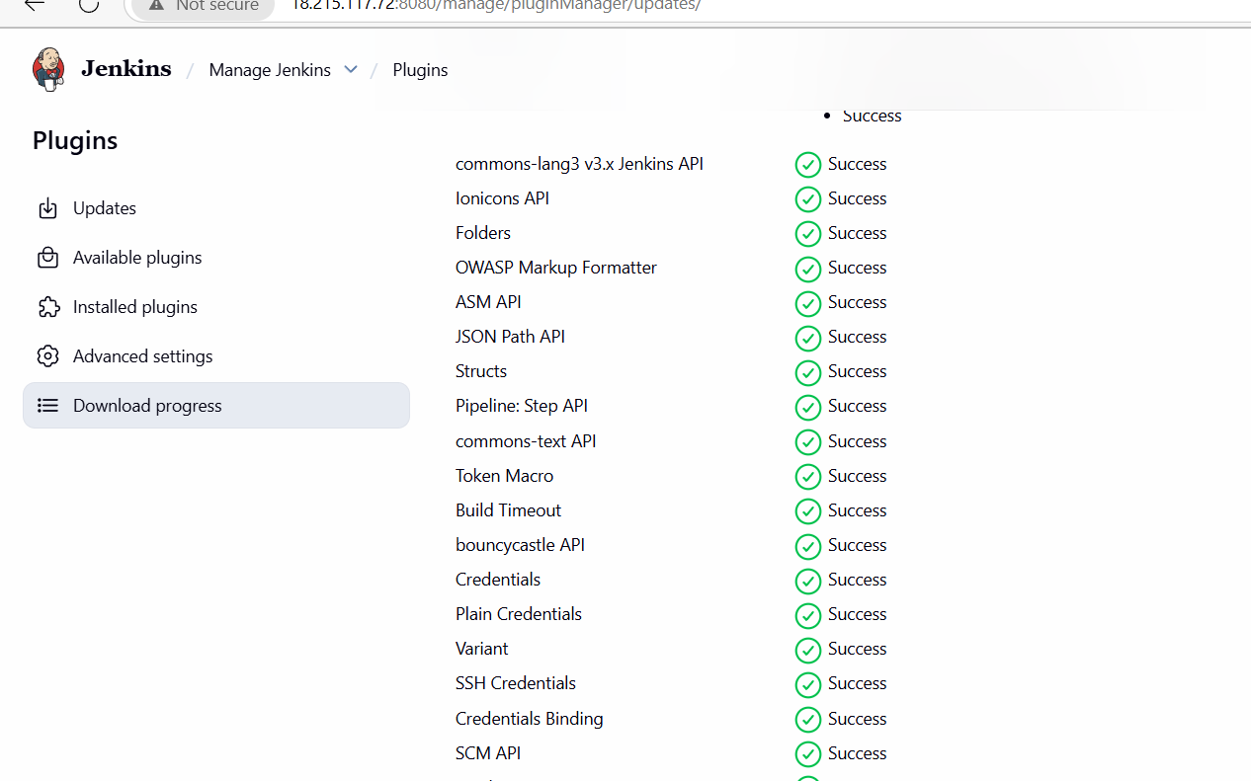
4.Configure labels and restrict the jobs to execute based on label only.
Add Node Label
If using master as agent:
Manage Jenkins → Nodes → Built-In Node → Configure
Add label:
dev-node
Save.
Restrict Job to Label
In any job config:
✔ Restrict where this project can be run
Label Expression:
dev-node
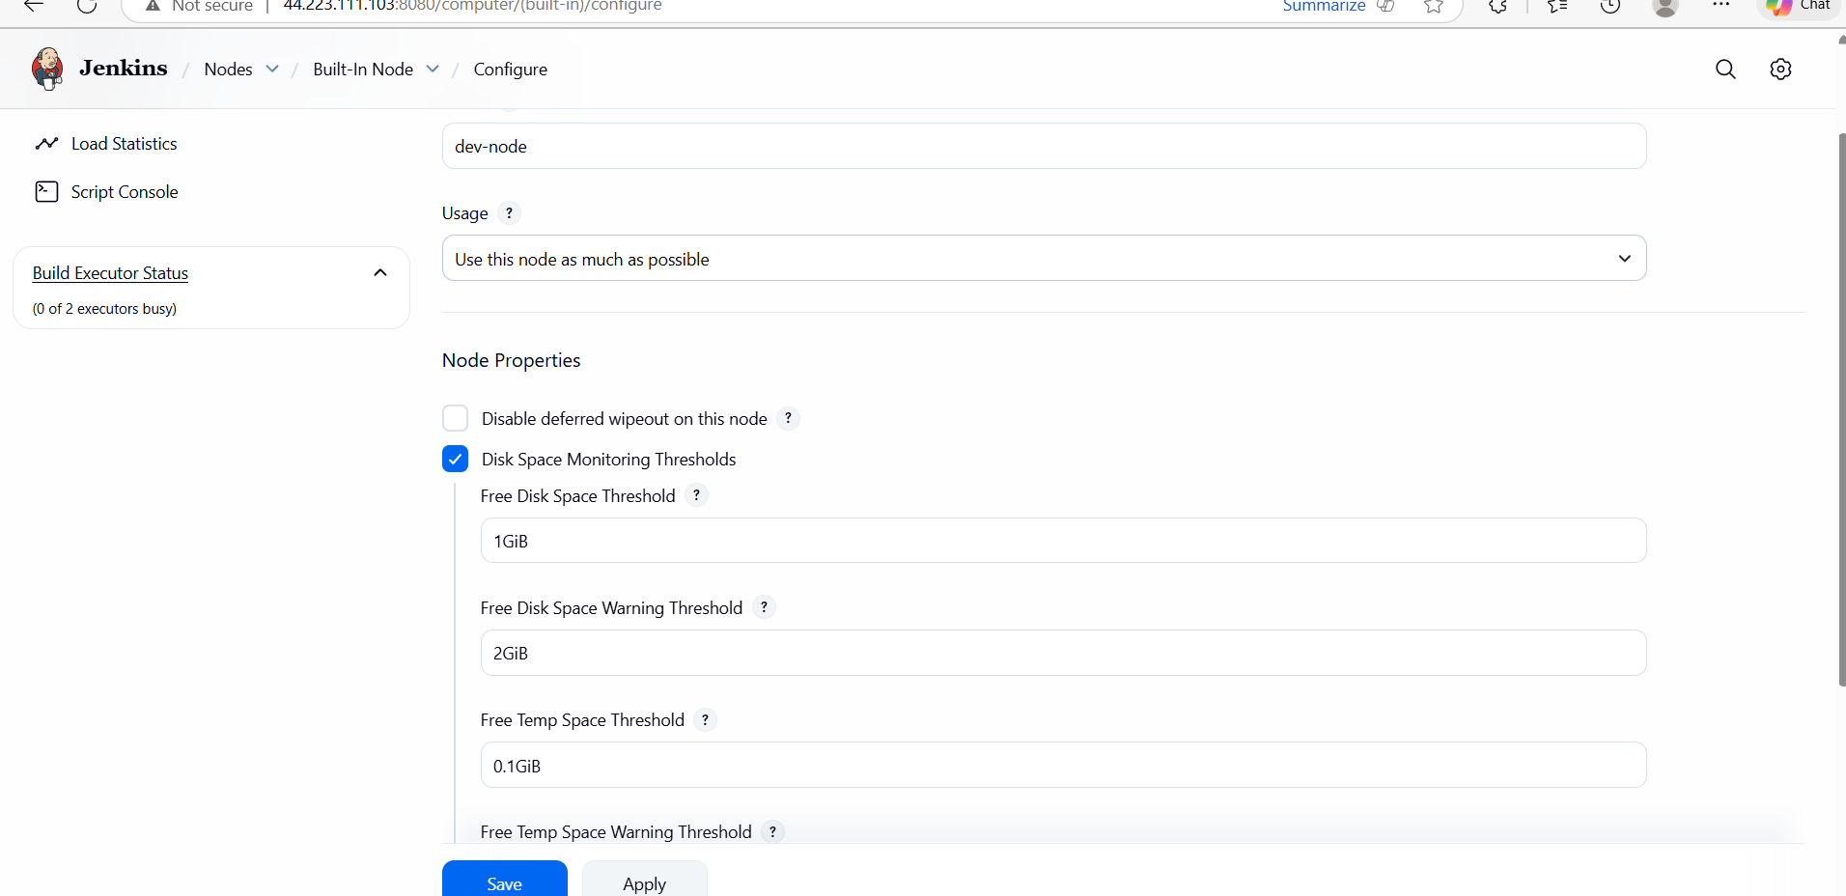
Restrict Job to Label
In any job config:
✔ Restrict where this project can be run
Label Expression:
dev-node
This ensures job runs only on nodes with that label.

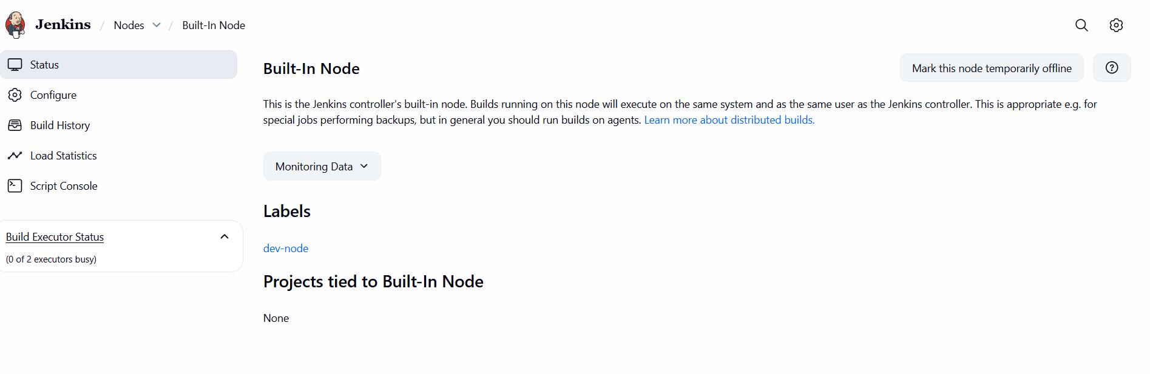
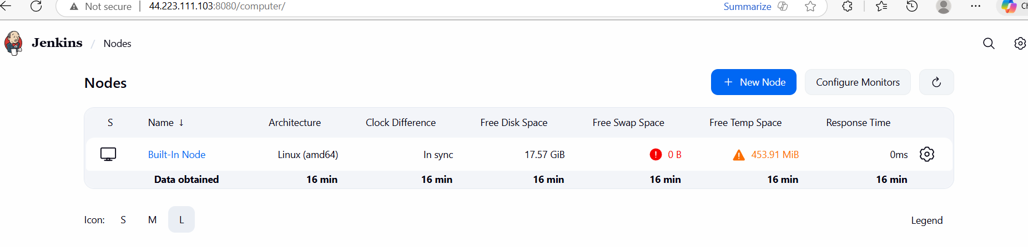

5.Create Three sample jobs using the below
Job 1: Sample-Build
- New Item → Freestyle → sample-build
- Source Code: Git → repo URL
Save → Build Now.
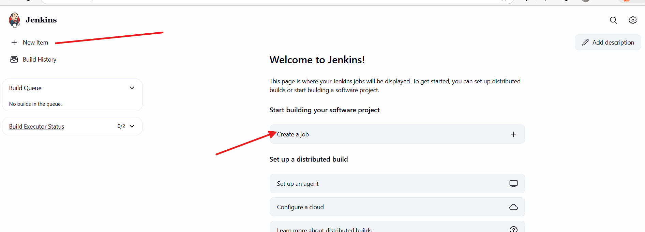
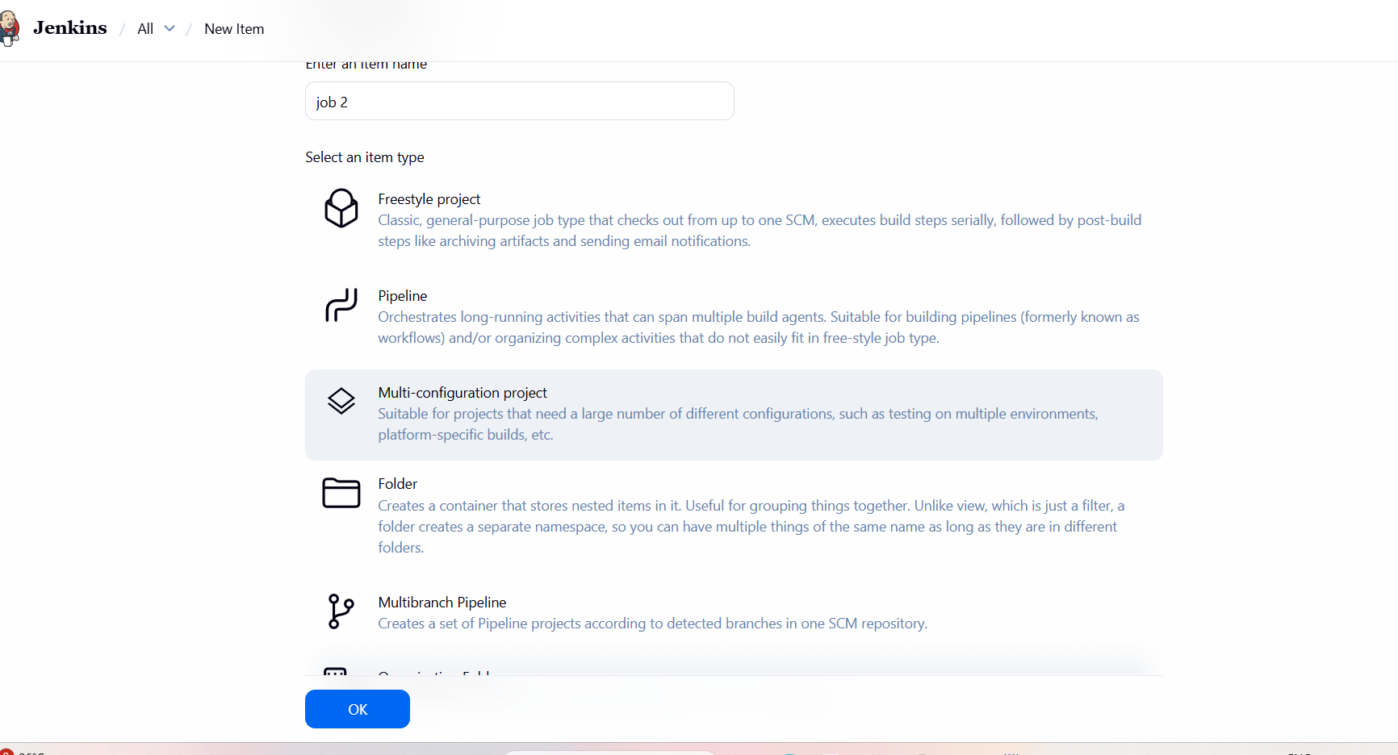
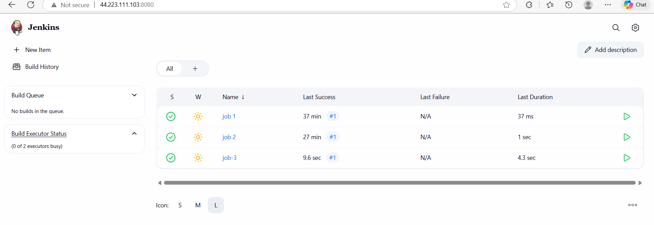

- Create one Jenkins job using git hub Private repository.
Task Title
Creation and Execution of a Jenkins Freestyle Job Integrated with GitHub
Objective
To create a Freestyle Job in Jenkins, connect it to a GitHub repository, execute builds, and
verify successful source code checkout and job execution.
Prerequisites
• Jenkins installed and running on an EC2/Linux server
• Jenkins service accessible via browser (http://<server-ip>:8080)
• Git installed on the Jenkins server
• Internet access from Jenkins server
• Public GitHub repository URL
• Jenkins user with admin privileges
Step-by-Step Implementation
Step 1: Create a New Jenkins Job
1. Log in to Jenkins Dashboard
2. Click New Item
3. Enter job name: first-job
4. Select Freestyle project
5. Click OK
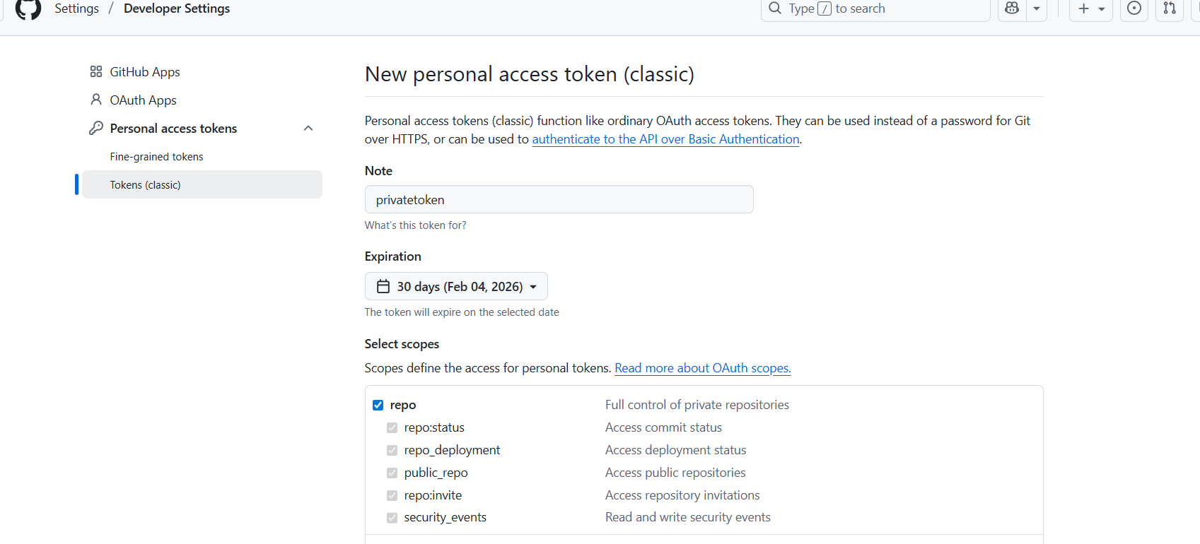

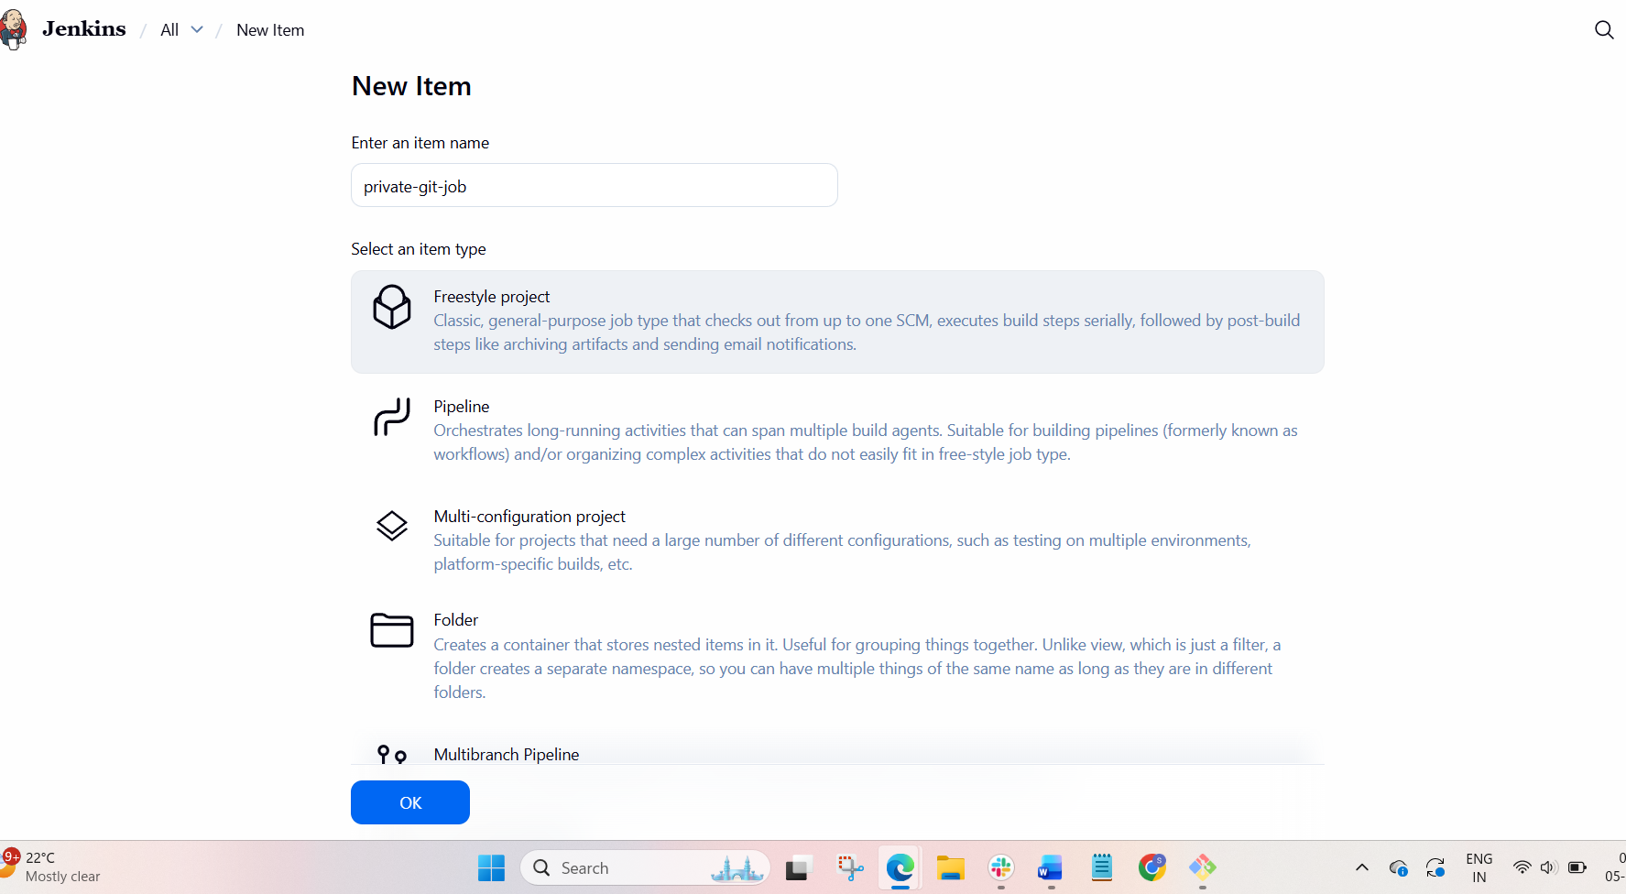
Step 2: Configure Job Settings
1. Navigate to Configure for first-job
2. Under General:
o Keep default settings
o Ensure job is Enabled
Step 3: Configure Source Code Management
1. Select Git under Source Code Management
2. Enter Repository URL:
https://github.com/betawins/Techie_horizon_Login_app.git
3. Credentials: None (public repository)
4. Branch: */master (default)

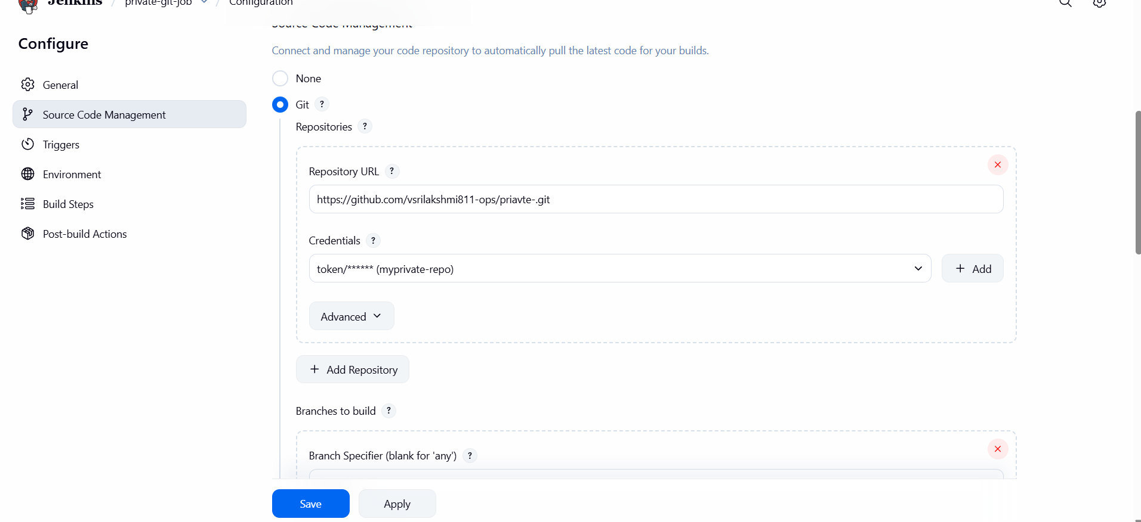
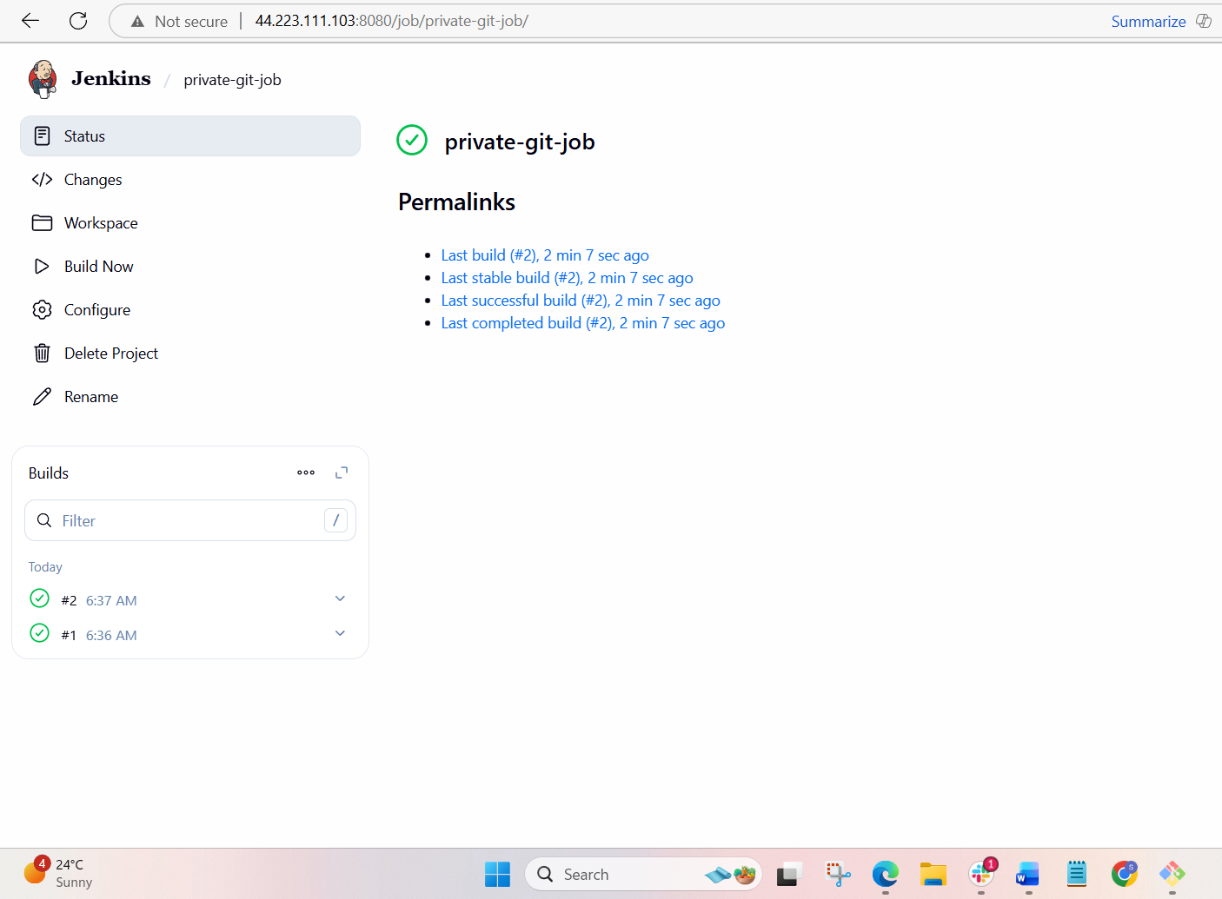
Validation Steps
• Jenkins build status shows green (Success)
• Console Output confirms:
o git clone successful
o Correct branch checked out
• Jenkins dashboard shows:
o Last Successful Build
o Last Stable Build
• Workspace contains repository source code
Conclusion
The Jenkins Freestyle job first-job was successfully created and configured. The job
correctly integrated with a GitHub repository, executed builds without errors, and validated
source code checkout both via Jenkins Console Output and server workspace verification.
This confirms successful Jenkins–GitHub integration and establishes a foundation for further

